**BST 203 Lab 1: ANOVA**

**July 25th 2022**

**Review: Analysis of Variance (Chapter 12)**

* Analysis of variance (ANOVA) is an extension of the two-sample t-test to k > 2 groups.
* The basic idea:
* Two sources of variation:

1. “Within group variation” – variation of individual values around their group mean.



1. “Between group variation” – variation of the group means around the overall mean.



where



* If  is big relative to, then at least one of the means is different from the others.

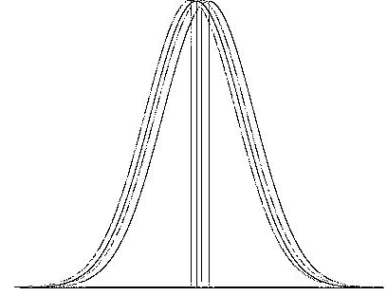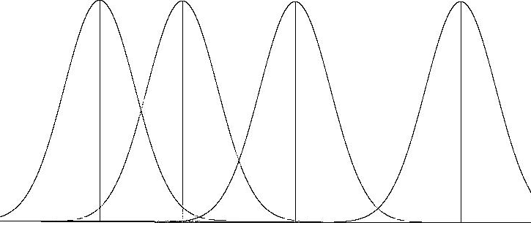

* Assumptions
* Samples from the k populations are independent.
* Samples from the k populations are normally distributed.
* Variances in the k populations are equal. i.e., 1 = 2 =  = k

(We do not test this assumption, it is assumed true. You can do Bartlett's test with STATA)

* Test Statistic



* F distribution:
* Two types of degrees of freedom:

Numerator: k-1 (corresponds to the df for variation between groups)

Denominator: n-k (corresponds to the df for variation within groups)

* The F-statistic cannot assume negative values (do NOT double the p-value)

* Multiple comparisons:
* If null hypothesis is rejected, conclude that at least one of the means is different from the others.
* To determine which means are different, perform all  pair-wise comparisons of the means with two-sample t-tests and use a Bonferroni correction  because the tests are not independent.
* In each pair-wise t-test, use  as the pooled standard deviation and *n-k* degrees of freedom (don’t forget to double the p-value for 2-sided tests when using a t-test).
* The Bonferroni correction is highly conservative (low power) and may fail to reject a difference between means when one actually exists.

# Example

We will look at a dataset collected from the 2010 World Cup. The data contains variables regarding a player’s name, country, position, minutes played, and number of passes. We’re interested in seeing if different positions pass more than others. The three positions listed are forward, midfielder, and defender. We will use a transformed version of passes called logpasses (the log of passes). The data, lab1.dta, can be found on the course website in the data section of the “Labs” tab.

* What is the overall mean logpasses? What is the sample size/ mean logpasses / variance in each group?

Helpful STATA code:

summarize logpasses

sort position

by position : summarize logpasses

* Are the assumptions met for ANOVA?

Helpful STATA code:

histogram logpasses, by(position) freq

graph box logpasses, over(position)

* State the null and alternative hypotheses.
* What is the estimate of the within-groups variance (by hand)?
* What is the estimate of the between-groups variance?
* What is the value of the test statistic and what distribution does the test statistic follow?
* What is the p-value for the test?
* What do you conclude?
* Perform ANOVA with STATA:

**REFERENCE: oneway [variable of interest] [group variable], [correction]**

. oneway logpasses position, bonferroni

                        Analysis of Variance

    Source              SS         df      MS            F     Prob > F

------------------------------------------------------------------------

Between groups      20.7070961      2   10.3535481     16.78     0.0000

 Within groups      214.083692    347   .616955885

------------------------------------------------------------------------

    Total           234.790788    349   .672752974

Bartlett's test for equal variances:  chi2(2) =   0.6581  Prob>chi2 = 0.720

                     Comparison of logpasses by position

                                (Bonferroni)

Row Mean-|

Col Mean |   Defender    Forward

---------+----------------------

 Forward |   -.580234

         |      0.000

         |

Midfield |    .013295    .593529

         |      1.000      0.000

* Should any other tests be conducted? Explain.
* How many pair-wise tests do you have had to perform to determine where the difference is?
* What is the new Type I error rate after adjusting for the multiple tests?
* Note that when presenting the p-values for the Bonferroni tests, STATA scales the values such that you should compare them to_____ and not ______. What do we conclude?
* Generate the table of contrasts (i.e. differences between pairs of means) and Bonferroni corrected p-values and 95% confidence intervals. Present and interpret the 95% Bonferroni corrected confidence interval for the difference between the mean logpasses for Forward vs Defender positions.

**REFERENCE:**

**encode position, gen(posgp) <- note this command ensures the variable ‘position’ is a**

**categorical, not a string variable**

**pwmean [variable of interest], over(group variable) mcompare(bonferroni) effects**

**Stata Tips for ANOVA**

Unlike the one- and two-sample hypothesis tests for the mean, STATA requires you to have the entire dataset and not just the summary statistics to perform ANOVA.

From the *Statistics* menu, choose *linear models and related*/*ANOVA* then choose *One-way ANOVA*. In the resulting window, choose the response variable and the factor (group) variable. If you’re doing a multiple comparison procedure, check the appropriate box.